Name: _______________________________ Date:_______________
T: Counting on in 5’s
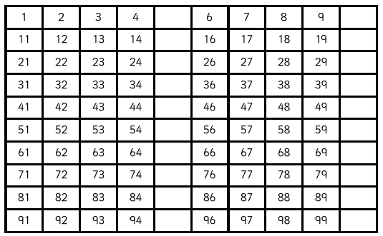
Practise ‘skip counting’. Fill in the missing numbers using a coloured pencil or pen, so you can see the pattern of 5’s.
Complete the missing numbers in the sequences.
